ENERGY, ENERGY CHANGES AND BIOTECHNOLOGY

BEHAVIOUR OBJECTIVES
At the end of this lesson, students should be able to;
- list forms of energy.
- mention forms and types of energy resource [renewable and non-renewable].
- draw energy profiles for exothermic and endothermic reactions.
- explicate the concept of thermodynamics.
- define various heat of reactions.
- explain ∆G, ∆S and ∆H and connection between them.

Energy is the ability or capacity to do work. All matter possess energy in one form or the other.
There are various forms of energy, as every aspect of work is powered by a form of energy. The various forms of energy are interconvertible as energy changes from one form to another. It is worthy to note that energy change always obeys the law of conversation of energy.
Forms of energy
- Potential Energy
- Kinetic Energy
- Light Energy
- Thermal Energy
- Electrical Energy
- Sound Energy
- Chemical Energy
- Nuclear Energy
- Gravitational Energy
- Mechanical Energy

ENERGY RESOURCES
Energy Resources are materials, elements that can be used as a basis or source of energy. They used to produce energy.
There are primarily two energy resources;
- Non-Renewable Energy Resources: Energy Resources that are exhaustible and cannot be replaced once they are used up or takes millions of years to form again. Sources includes; natural gas, petroleum, coal, uranium, phosphate.
Advantages
- High energy output
- Easy to produce and use
- Abundance and affordability

Disadvantages
- Exhaustible
- Chemical and particulate matter pollution
- Non-recyclable and difficult disposal of residues and by-products

- Renewable Energy Resources: Energy Resources that comes from a source that is constantly renewed. So, they are not exhaustible, rather are constantly replenished. Sources include; Sun, wind, falling water (hydropower), heat from the earth (geothermal), plant materials (biomass), waves, ocean currents.

Advantages
- Non-exhaustible and Reliable
- Less pollutive
- Increases public health and wellbeing standards
Disadvantages
- Higher initial costs
- Lower efficiency
- Intermittent or seasonal

EXOTHERMIC AND ENDOTHERMIC REACTIONS
In reactions, we talk about system and surroundings. The system is the collective substances in the reaction such as the reactants and products, while the surroundings are everything around the reaction that is not directly involved in the reaction such as the reaction flask and the room.

ENDOTHERMIC REATION: reaction in which heat is absorbed from the surroundings. During which, heat is absorbed and transferred from the surrounding to the reactants and the temperature of the reaction mixture decreases.
Examples
- Thermal dissociation of ammonium chloride
NH₄Cl_{(s)} → NH_{3(g)} + HCl_{(g)}
- Thermal decomposition of potassium trioxochlorate (V)
2KClO_{3(aq)} → 2KCl_{(s)} + 3O_{2(g)}
- Photosynthesis in plants
- Thermal decomposition of calcium trioxocarbonate (IV)
CaCO_{3(s)} → CaO_{(s)} + CO_{2(g)}

EXOTHERMIC REACTION: reaction in which heat is given off to the surrounding. During which, heat is liberated from the chemicals to the surroundings and the temperature of the reaction mixture increases.

Examples
- Reaction between calcium oxide and water
  - CaO_{(s)} + H₂O_{(l)} → Ca(OH)₂
- Neutralization reaction
  - HCl_{(aq)} + NaOH_{(aq)} → NaCl_{(aq)} + H₂O_{(l)}
- Addition of concentrated acid to water
- Combustion of fuel

ENERGY PROFILE DIAGRAM

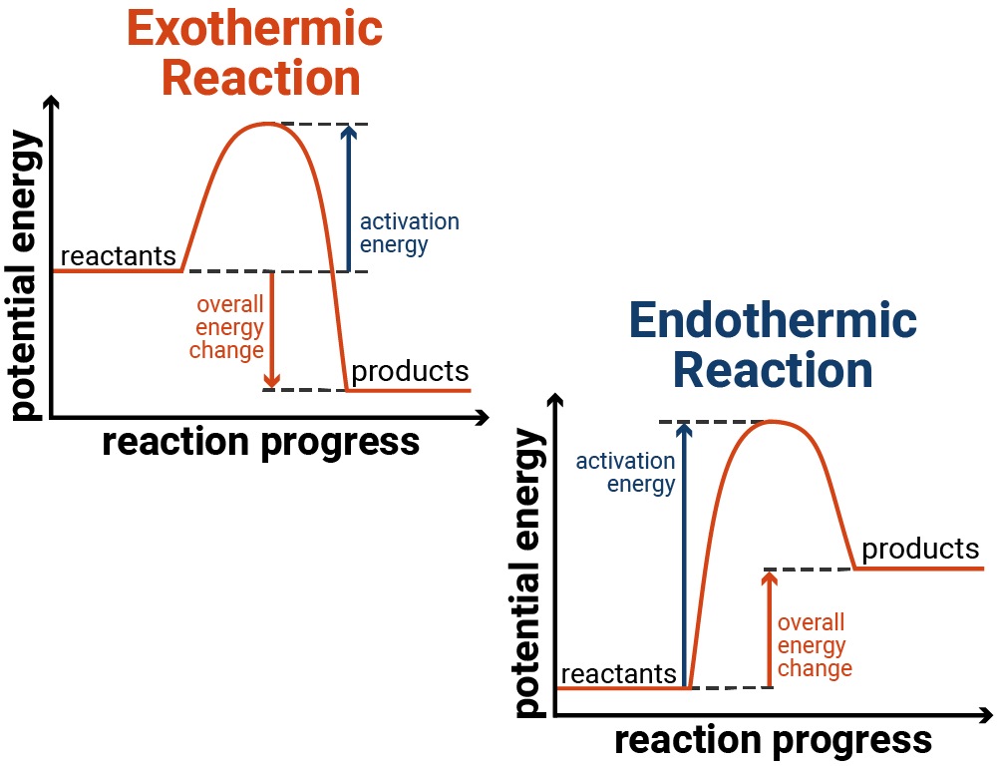

CHEMICAL THERMODYNAMICS
Thermodynamics is the study of relationships between heat and other forms of energy. Heat is represented by (q). all other forms of energy are classified to be work in thermodynamics and are represented by (w). The relationships between heat and work is expressed in the Laws of Thermodynamics.

LAW OF THERMODYNAMICS
1ST LAW OF THERMODYNAMICS
First law of thermodynamics states that in a chemical reaction, energy can neither be created nor destroyed but can only be converted from one form to another.
This is also called the Law of conversation of energy. Energy can either flow in and out of the system either by heat or work. The heat that flows into a system is called the Internal energy (U).
The internal energy changes when;
- Heat is evolved or absorbed
- Work is done by or on the system.

The change in internal energy can be represented by;
Change in internal energy = Heat absorbed by the system + work done
(ΔU) = (q) + (w)
When work is done by the system; w = negative
When work is done on the system; w = positive
When heat is absorbed by the system; q = positive ( Endothermic Reaction)
When heat is evolved by the system; q = negative (Exothermic Reaction)

2ND LAW OF THERMODYNAMICS
2nd Law of Thermodynamics states that a spontaneous process occurs only if there is an increase in the entropy of a system and its surroundings.
Since entropy is simply the degree of disorderliness, so this implies that heat will only move from a hot body to a cold body and not the other way around, the only condition for that to happen is when sufficient energy is applied.
ENTHALPY(H) is the total heat content of a system.
Total enthalpy cannot be determined directly but enthalpy change (ΔH) can be measured. It is basically the amount of energy involved in a reaction. So, we can call enthalpy- heat of reaction.
∆H = ∑H (products) - ∑H (reactants)
The unit for enthalpy change (∆H) is Joules(J)
The value can either be negative or positive.
Endothermic reaction = ΔH is positive. That is, the heat content of the products is greater than that of the reactants.
Exothermic reaction = ∆H is negative. That is, the heat content of the product is less than that of the reactants.

TYPES OF HEAT CHANGE IN CHEMICAL REACTIONS

- Heat of Neutralization, ΔH_{n}: The amount of heat evolved when one mole of hydrogen ion. H⁺, from an acid reacts with 1mole of hydroxide ion, OH⁻, from alkali to form 1 mole of water. It is always an exothermic reaction.
H⁺_{(aq)} + OH⁻_{(aq)} → H₂O_{(l)} ∆H_{n} = -57.4KJmol⁻¹
Ex: 0.25moles of HCl reacts with 0.25moles of NaOH to produce NaCl and H₂O. Given that 3000J of heat was evolved in the process, determine the heat of neutralization of NaOH by HCl.
HCl + NaOH → NaCl + H₂O
1 : 1 1 : 1
0.25 moles require 3000J
1 mole will require = $\frac{1 ×3000}{0.25}$= 12000J/mol = -12000J/mol

- Heat of Combustion, ∆H_{c}: the amount of heat evolved when one mole of a substance is burned completely in oxygen. It is always an exothermic reaction.
Ex: 0.46g of ethanol when burned raised the temperature of 50g of water by 14.3k. Calculate the heat of combustion of ethanol. [C=12, O=16, H=1, specific heat capacity of water=4.2Jg⁻¹k⁻¹]
M= 0.46g molar mass (C₂H₅OH) = (2(12) + 5(1) + 1 + 16) = 46g/mol
Q=mcΔθ = 50 × 4.2 × 14.3 = 3003J
0.46g of C₂H₅OH requires 3003J of heat
46g will require = $\frac{46 ×3003}{0.46}$ = 300300J/mol = -300300J/mol

- Heat of Formation, ∆H_{f}: the amount of heat evolved or absorbed when one mole of a substance is formed from its elements.
Ex: when 4.5g of liquid water was formed by burning hydrogen gas in oxygen, -72KJ of heat was given off. Calculate the standard heat of formation of water
H_{2(g)} + ½ O_{2(g)} → H₂O_{(l)}
4.5g of liquid water produces -72KJ of heat
18g of liquid water will produce = $\frac{-72 ×18}{4.5}$ = -288J/mol

- Heat of Solution, ∆H_{s}: the amount of heat absorbed or evolved when 1 mole of substance is dissolved in so much water that further dilution results in no detectable heat change.
Dissolution process involves two steps and each step is associated by heat change. they are;
- The water molecules split up the ions in the crystal into free ions. The energy associated is Lattice Energy. NaCl_{(s)} → Na⁺_{(g)} Cl⁻_{(g)}
- The free ions are hydrated by water molecules. The energy associated is Hydration Energy. Na⁺_{(g)}Cl⁻_{(g)} → Na⁺_{(aq)} Cl⁻_{(aq)}
Dissolution is negative if;
Lattice Energy < Hydration Energy
Dissolution is positive if;
Lattice Energy > Hydration Energy

ENTROPY AND GIBB’S FREE ENERGY
A spontaneous reaction is a reaction that has the potential to occur on its own without the assistance of any external agent. E.g. cellular respiration, breathing. (photosynthesis is not a spontaneous reaction). The factors that determines the spontaneity of a reaction are Entropy, Gibb’s Free Energy
- Entropy(S): the measure of the degree of disorderliness or randomness of a system. The change in entropy is denoted by ∆S.
∆S = S _{products} - S _{reactants} S.I unit for entropy is JK⁻¹mol⁻¹
When a reversible chemical change occurs at constant temperature; ΔS = $\frac{∆H}{T}$

Entropy increases from solid to liquid to gaseous state.
If heat is absorbed; ΔS is positive
If heat is evolved; ΔS is negative

Ex 1: Calculate the entropy change for the reaction
H_{2(g)} + Cl_{2(g)} → 2HCl_{(g)}
Given that SᶿH₂ = 131JK⁻¹mol⁻¹, SᶿCl₂ = 223JK⁻¹mol⁻¹, SᶿHCl = 187JK⁻¹mol⁻¹
Solution: H_{2(g)} + Cl_{2(g)} → 2HCl_{(g)}
∆S = S _{products} - S _{reactants}
∆S = 2(187) – (131 + 223)
∆S = 374 – 354
∆S = +20 JK⁻¹mol⁻¹

Ex 2: calculate ΔS for the conversion of one mole of liquid water vapour at 100⁰C , given that the heat of vaporization of water = 2260.87Jg⁻¹
Mass of 1 mole of water = 18g
Heat content = 2260.87 × 18 = 40695.66J
ΔS = $\frac{∆H}{T}$ = $\frac{406995.66}{(100+273)}$ = 109.10Jk⁻¹mol⁻¹

- Gibb’s free energy: The energy available for doing work. The driving force that brings about a chemical change. it helps to determine whether a reaction will occur spontaneously or not. S.I unit =Joules
G =H -TS
∆G = ∆H -T∆S
At constant temperature, ∆G = -T∆S
When ∆G is negative, reaction is spontaneous
When ∆G is positive, reaction is non-spontaneous
When ∆G is zero, the system is in equilibrium

Ex 3: C_{(s)} + O_{2(g)} → CO_{2(g)} is carried out at a temperature of 57ºC. if the enthalpy change is -5000J and entropy change is +15J. calculate the free energy change.

Sol: ∆G = ∆H -T∆S
T = 57 + 273K = 330K, ∆H = -5000J, ∆S = +15J
∆G = - 5000 – (330 * 15)
∆G = -9950J or 9.95kJ

CONDITION FOR SPONTANEITY IN CHEMICAL REACTIONS
- Positive Entropy Change; ΔS = +ve
- Negative Gibbs free energy; ΔG = -ve

DRILL QUESTIONS

- A chemical reaction with entropy changes of 20JK⁻¹ and free energy change +55000J occurred at -23ºC. calculate the enthalpy change?
- 55,460J
- 44,540J
- 50,000J
- 60,000J

- If the value of ∆H is positive for a reaction, it means that the reaction is?
- Exothermic
- Endothermic
- Spontaneous
- Slow

- Which of the following equation shows that a reaction is sin equilibrium
- ΔG < 0
- ΔG = ΔH -TΔS
- ΔG > 0
- ΔG = 0

- NH_{3(g)} + HCl_{(g)} → NH₄Cl_{(s)} the entropy change in the system above is
- Indeterminate
- Zero
- Negative
- Positive

- Which of the following is not a renewable energy source?
- Uranium
- Falling water
- Wind
- Geothermal

ANSWER
- D
- B
- D
- C
- A

